Aerodynamic shaping of a crew escape system – Axisymmetric analysis

Venkata Subrahmanyam B, Sreenivasulu J, Sanjoy Kumar Saha, Dr. Patil M M and Dr. Ashok V

Aeronautics Entity

Vikram Sarabhai Space Centre, Thiruvanthapuram, India.

(sanjoy_kumar@vssc.gov.in, sanjoy254@gmail.com)

Abstract
Parametric studies over two different shapes (conical and cone+ogive) of the CES have been studied here with axi-symmetric CFD simulations at 10 different Mach numbers using CFD++ commercial software. Configuration leading to lower transonic normal shock strength, No/smaller separation at the flare beginning is achieved to achieve lower in-flight noise levels. Shorter flare length of the CES flare region is also ensured to achieve higher static margin.

Keywords: CES, Shock, In-flight noise, 2-D, CFD, Ogive, Conical

Nomenclature:
θ : Turning Angle in degrees
R_{O} : Radius (in m)
CES : Crew Escape System
CM : Crew Module

Introduction:
Crew Escape System (CES) pulls Crew Module (CM) away from the launch vehicle and takes it to a safe altitude and range in case of abort during the ascent mission. CES is essential for manned missions and is typically tractor type configuration with a solid motors preferred due to high reliability and high thrust levels. CM is housed inside the CES at the base region/rear potion. Solid motors are placed ahead when the diameter is less than the CES diameter at the base. The two regions of different diameter are joined by a flare. The flare is typically conical in shape (e.g Soyuz, Shenzhou, Saturn etc). The configuration design of the CES should ensure that the static and dynamic loads on the structure to be minimal to aid in optimizing the mass of the structure. Upon designing and realization of flight hardware, they are tested for various environmental conditions. Acoustic testing is one such environmental testing that is essential for arriving of vibration specifications of the components in various sub-assemblies. In-flight noise during the atmospheric phase of the regular ascent mission is the prime contributors for the environmental test levels for various forebody structures and these levels in-turn dictates the vibration levels of the various subsystems on the forward region of launch vehicle. In-flight noise in the forebody region is governed mainly by interaction of transonic normal shock with boundary layer and the unsteadiness in the separated flow. The occurance of stronger shock further leads to separation bubble that increases the spatial extent of higher in-flight noise levels. Further, the in-flight noise in the region of shock boundary layer interaction peaks at lower frequencies where the structural damping is lower. Hence, reduction of transonic shock strength and extent of separated flow is required to reduce the in-flight noise levels, which in turn aids in reduction of the vibration specification of underlying components. The aerodynamic configuration should also be ensured to have positive static margin from aerodynamic stability aspect. Hence, proper shaping of external configuration of CES is very essential that gives required static stability along with lower in-flight noise levels.

Flare region for Orion Launch Abort System was initially double cone (for ARES 1-X vehicle configuration) and later changed to cone-ogive (for ARES 1 vehicle configuration). The change in the shape is also motivated by the reduction of in-flight noise levels on the forebody during the ascent phase. Extensive studies were conducted on various flared configurations (conical, ogive, cone+ogive etc) from Mach 0.5 to 2.5 to shortlist the best configuration and concluded that the cone+ogive configuration leads to lower in-flight noise levels (C_{P’rms} is lower by 20% - 30% lower at front end of ogive, 60% - 70% lower on CM region and 50% - 60% lower on Service Module) [1]. To assess the relative merits and demerits of the conical and cone-ogive flare for CES of Indian man mission, flow simulations were carried out over both types of the configurations.

Configurations studied, Grid generation, flow solver:
A schematic of the conical and cone+ogive variants of CES are shown in Figure 1. Conical CES is a one parameter family (flare angle θ₁) and cone+ogive CES is three parameter family (flare angle (θ₁), flare-ogive intersection angle (θ₂) and ogive radius (R_{O})). For quick and reasonably good results other protrusions and grid fins are not simulated in the present study.
Details of the configurations (conical and cone+ogive) studied in the present work are tabulated and given in Table 1(a) and Table 1(b). Studies were carried out over 8 configurations of conical flare (with θ₁ varying from 16˚ to 30˚) and 125 configurations of cone-ogive flare (with θ₁ and θ₂ varying between 16˚ to 30˚ (ensuring θ₁ ≤ θ₂) at various R_{O} (in steps of 1.0 m)). The maximum R_{O} possible physically for various combinations of θ₁ and θ₂ are given in Table 1(b).
Axi-symmetric grid is generated for conical and cone+ogive configurations are generated in POINTWISE commercial software and the. Glyph scripting available in POINTWISE software for this process to ensure automation. Separate glyph scripts were written for conical and cone+ogive CES grid generation. The first cell is ensured to be within y+ = 1 and the grid is relaxed in the wall normal direction by a factor of 1.2.
Axi-symmetric CFD simulations are carried out using CFD++ commercial software. The simulations in the current study are carried out using Realizeable k-ε turbulence model. Fluxes at the interface are computed by HLLC based approximate Riemann solver and point implicit time discretization technique is employed. The spatial discretization is second order accurate in space and Continuous type TVD limiter is used.

Objectives
Axi-symmetric CFD simulations for all the configurations are carried out at 10 different Mach numbers. Peak in-flight noise levels occur during supersonic Mach numbers at the CES-Flare compression corners where as it occurs during lower transonic Mach numbers (M<1.0) on the cylinder region following the flare [1]. Hence, the current analysis is carried out from Mach 0.70 to 1.60 in steps of 0.1 to capture the flow features in both the regions. While finalising the configuration and analysis of the results, following aspects are considered-
- Lower transonic normal shock strength (for lower in-flight noise) on cylinder following CES flare
- No/smaller separation at the flare beginning (for decreasing low frequency oscillations) at supersonic Mach numbers
- Shorter length of the CES flare region (to increase the static margin)

Configurational changes with parametric variations:
To understand the variations in the configurations due to parametric variations in cone+ogive configurations, two out of the three parameters are held constant and the configurations are plotted for the three cases
Case 1: θ₁=θ₂=Constant, increasing R_{O}.
For such cases, the location of flare beginning doesn’t change with increase in R_{O} where as the cone-ogive junction moves upstream. The configurations resulting from fixing the θ₁= θ₂ =16˚ and varying the R_{O} from 1.0 to 12.0 m are shown in Figure 2.
Case 2: θ₁=constant, θ₂=Constant (θ₁≠θ₂), increasing R_{O}
Unlike case 1, the location of flare beginning moves downstream with increasing R_{O}. However, the movement of the cone-ogive junction is similar to case-1. Further, it was seen for other cases of θ₁ and θ₂ (not shown here) that the longitudinal traverse of flare starting location is higher for larger θ₂-θ₁. The configurations resulting from θ₁= 16˚, θ₂ =24˚and varying the R_{O} from 1.0 to 7.0 m are shown in Figure 3.
Case 3: θ₁=constant, R_{O} =Constant, increasing θ₂
In this case, for a given R_{O} and θ_{1,} the location of flare beginning moves downstream and cone-ogive junction moves upstream with increase in θ₂. Further, it was seen for other cases of θ₁ and θ₂ (not shown here), that the longitudinal traverse of flare starting location is higher for larger θ₂-θ₁. The configurations resulting from θ₁= 16˚, R_{O} = 5m and varying the θ₂ from 18˚ to 24˚ are shown in Figure 4.

Results and discussion:
a) Conical Configuration
The variation of Mach number around the various conical flare CES configurations for M∞=0.80 is shown in Figure 5. The figure shows that as the cone angle increases, flow is further expanded at the end of the flare and this leads to a transonic shock with higher shock strength (equal to P₂/P₁ where P₂ is pressure upstream of the shock andP₁ is pressure downstream of the shock), as shown in Figure 6, which further leads to shock induced separation. It can be noted that the flow is separated at the end of 30˚ flare and thus the transonic shock formed on the shear layer rather than on the body. To analyse the region of separation at the flare and on the cylinder region, skin friction coefficient (C_{f}) is analyzed and the region of separated flow is given by C_{f} < 0. The distribution of C_{f} for the conical CES with θ₁ varying from 16˚ to 30˚ is given in Figure 7. It is observed that flow separates at the cylinder following the flare in lower transonic Mach numbers (M<1.0) due to transonic normal shock. However, the critical Mach numbers (lowest free stream Mach number for which the flow become supersonic after the expansion on the CES flare and subsequently gets compressed by a normal shock) for higher θ₁ is lower and the corresponding shock strength increases. Due to this, the separation length increases with θ₁ and the separation bubble extending up to boat-tail for θ₁ > 26˚. Flow separates at the compression corner (beginning of the flare) for all the configurations at supersonic Mach numbers. However, the separation length increases with θ₁ due to the larger turning angle and hence the flow starts to separates even at M<1.0 for θ₁ > 22˚.
In other words, lower θ₁ is beneficial as critical Mach number increases and shock strength reduces, thus avoiding flow separation on the cylinder region. But the reduction of θ₁ will results in higher length of conical section which will increase the aerodynamic load on the fore-body. This in-turn reduces the static margin of the vehicle.

b) Cone - Ogive configuration:
The turning angle between the cone and ogive is restricted to 24˚ based on the observations of conical shape. Mach palette over the body is shown for two typical configurations in Figure 8. It is clear that as the ogive radius increases, the shock strength reduces due to the gradual expansion of flow over a longer length of ogive (as shown in Figure 9). The critical Mach numbers increases for higher R_{O} and results in lower shock strength and the separation is avoided for R_{O} > 3.0 m.. It is also noticed that flow separates at the first compression corner (beginning of the cone) but not at second compression corner (cone-ogive intersection) for lower R_{O} (refer Figure 10). As mentioned earlier, as R_{O} increases, the location of second interaction point (transition from cone to ogive) moves upstream. Due to this, the flow has to responds compression immediately after the first compression corner. For R_{O} > 5 m, these results in a merging of both the compression regions leading to a bigger separation bubble (Figure 11). Hence, higher ogive radius is also a problem for a given θ₁ and θ₂.

Further analysis were carried out with varying one parameter among R_{O}, θ_{1,} θ₂ with other two as constant. Analysis shows that the critical Mach numbers doesn’t change with θ₂ when the R_{O} is sufficiently higher. The distribution of τ_{x} for the cone+ogive CES with CES with θ₁= 18˚, R_{O} = 5.0 m and θ₂ varying from 18˚ to 24˚ is given in is given in Figure 10. The observations are grossly similar.

Based on the analysis, it can be concluded that for lower in-flight noise levels, CES configuration should have lower θ₁ and θ₂ to restrict the separation at the compression corners. This should be accompanied by higher R_{O} to increase the critical Mach number leading to lower transonic normal shock strength, thus avoiding flow separation on the cylinder (following the CES flare) region. Also, R_{O} shouldn’t be higher which may result in the merging of the compressions leading to bigger separation bubble. But reduction of θ₁ and θ₂ leads to an increase of the length of these conical regions. This will lead to a higher aerodynamic load on the fore body and reduction in static margin.

Conclusions:
Analysis is carried out over various conical and cone+ogive CES configurations and the candidate cone-ogive configurations are chosen with a minimal separation length at different regions on the CES geometry across the complete Mach number range of 0.7 to 1.6. The smaller separation bubble ensures that the peak in-flight noise levels in these regions are expected to be pushed towards higher frequencies. Since the structural damping is higher at higher frequencies, this design is expected to lead to lower vibration specifications for various components. The conflicting requirement of lower CES flare length and lower cone angle are addressed in finalizing the configurations. A list of candidate configurations with a separation length within 0.3 m is shown in Figure 12. Each choice of θ₁ and θ₂ may have a range of R_{O} that satisfy the required criterion of separation lengths. However, the overall length of the CES flare will be minimal for the highest Ro

References
- J Panda, Nathan J. Burnside, Steven X. S. Bauer, Stephen J. Scotti, James C. Ross, David M. Schuster, “Comparative study of external pressure fluctuations on various configurations of launch abort system and CEV” , 15th AIAA/CEAS conference

Table 1: Details of the configurations used in the present study (a) Conical (b) Cone + ogive configurations
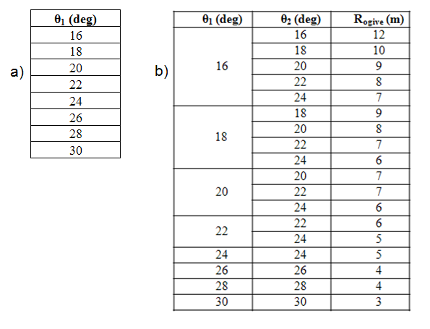

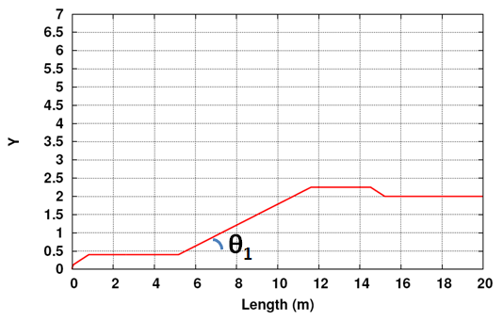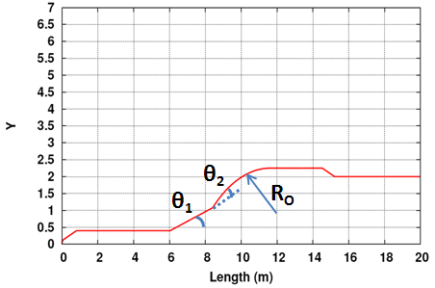
- Conical flare b) cone+ogive flare
Figure 1: Schematic of CES configuration

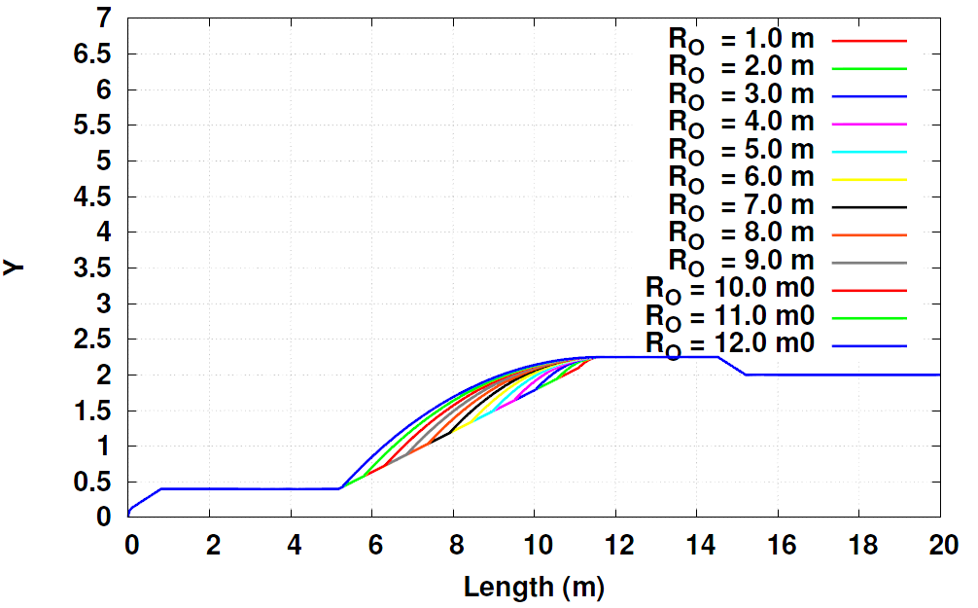
Figure 2: Schematic of CES configurations with θ₁= θ₂ =16˚ and varying R_{O}
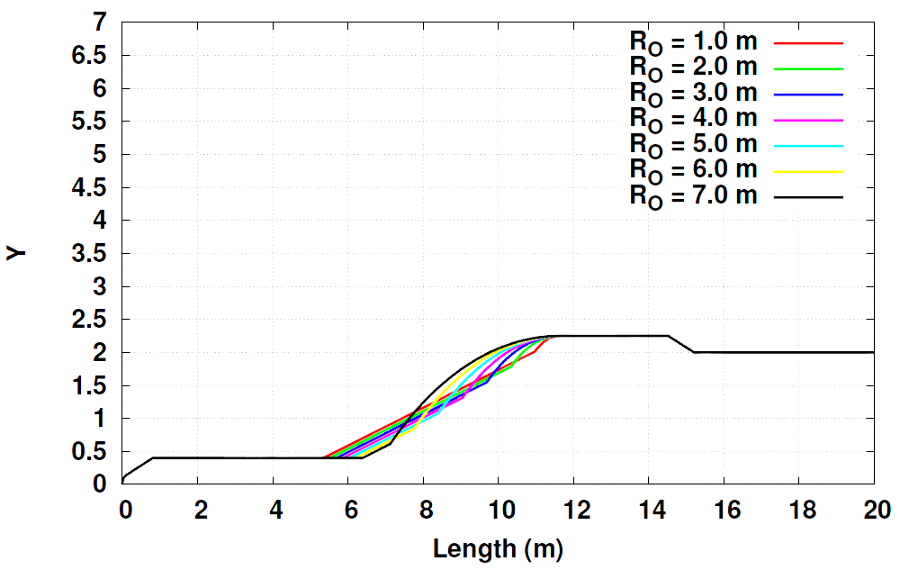
Figure 3: Schematic of CES configurations with θ₁= 16˚, θ₂ =24˚ and varying R_{O}
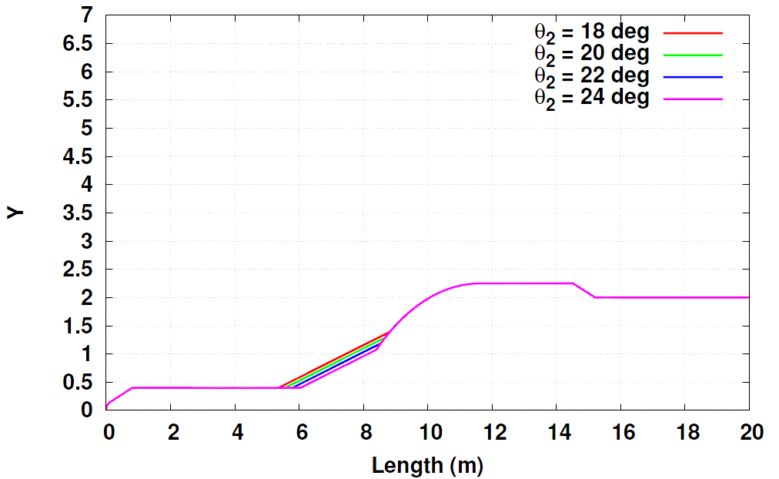
Figure 4: Schematic of CES configurations with θ₁= 16˚, R_{O} = 5m and varying θ₂
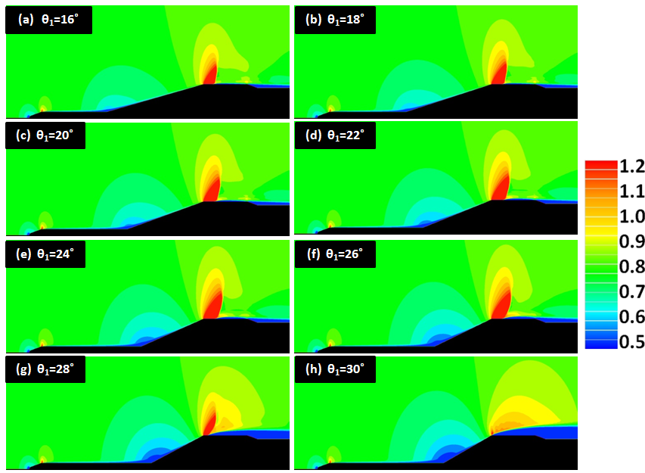
Figure 5: Mach number distribution over various conical CES configurations for M∞ = 0.8
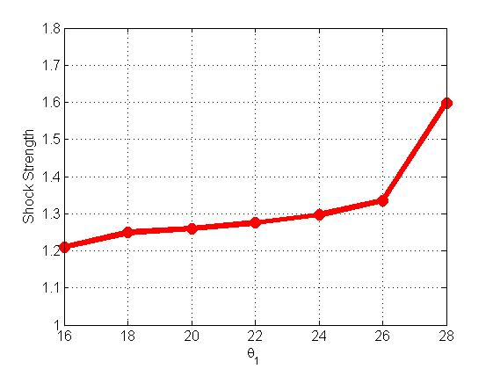
Figure 6: Variation of transonic shock strength on the cylindrical region for conical CES
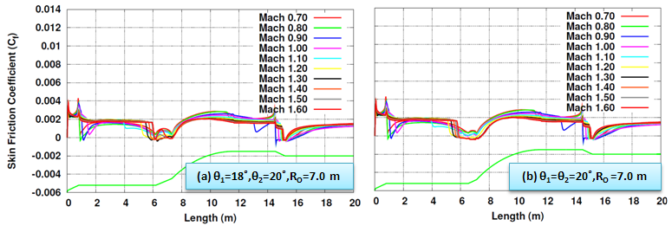
Figure 7: Comparison of skin friction coefficient (C_{f}) along the length on various conical CES configurations
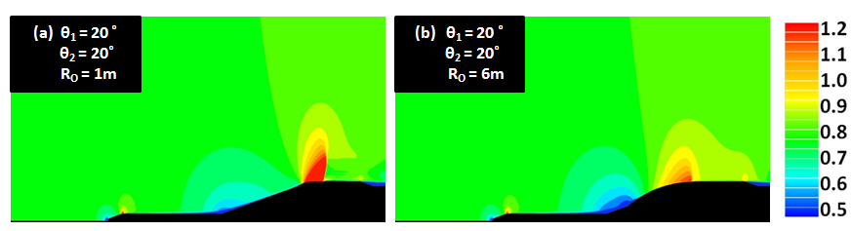
Figure 8: Variation Mach number palette over various cone-ogive CES configurations

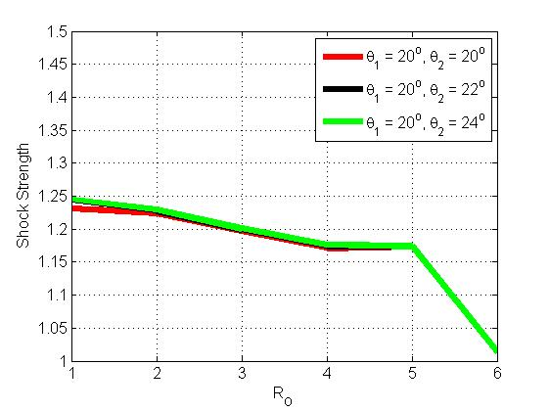
Figure 9: Variation of transonic shock strength on the cylindrical region with RO for cone ogive CES (θ1=20˚)
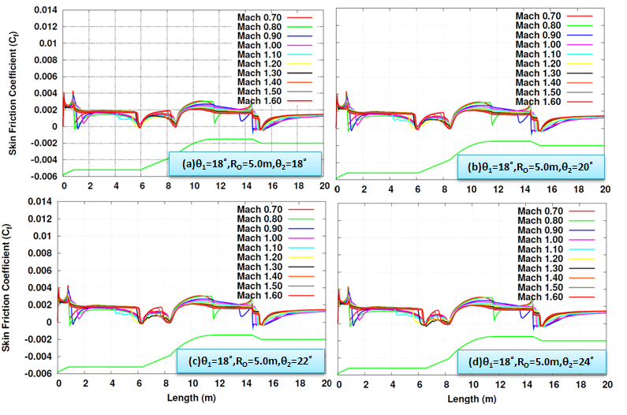
Figure 10: Comparison of skin friction coefficient (C_{f}) along the length on various cone-ogive CES configurations with θ₁= 18˚, R_{O} = 5.0 m and varying θ₂

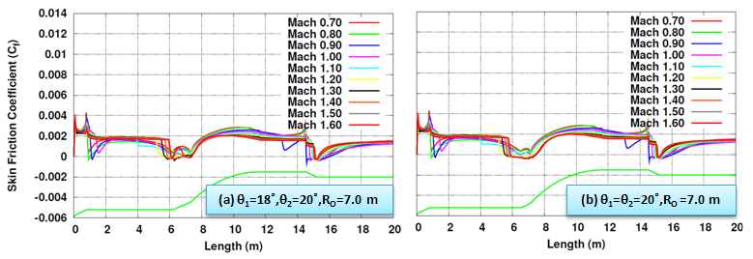
Figure 11: Comparison of skin friction coefficient (C_{f}) along the length on various cone-ogive CES configurations (R_{O}=7m)
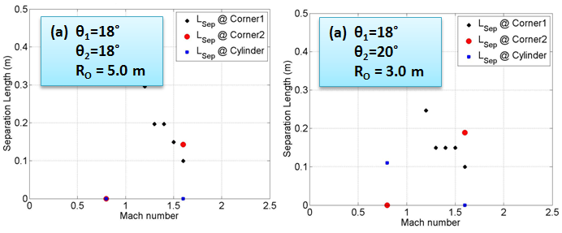
Figure 12: Comparison of separation lengths at three regions (Corner-1, Corner-2 and cylinder region) for the candidate CES configurations with θ₁= 18˚ and Lsep < 0.3 m

